EXPERIMENT 14 : Complex number addition using class
- ALGORITHM;
Step 1: Start
Step 2: Define a class Complex with attributes:
  - real
  - imag
Step 3: Define method initComplex()
  - Read two integers from user input
  - Assign them to real and imag
Step 4: Define method sum(c1, c2)
  - Set real = c1.real + c2.real
  - Set imag = c1.imag + c2.imag
Step 5: Define method display()
  - If imag >= 0, print "real + imag i"
  - Else, print "real - |imag| i"
Step 6: Create three objects:
  - c1, c2, c3 of class Complex
Step 7: Call initComplex() for c1
  - Input first complex number
Step 8: Call initComplex() for c2
  - Input second complex number
Step 9: Call sum(c1, c2) using c3
  - Store result in c3
Step 10: Call display() using c3
  - Display the result
Step 11: Stop B]FLOWCHART:

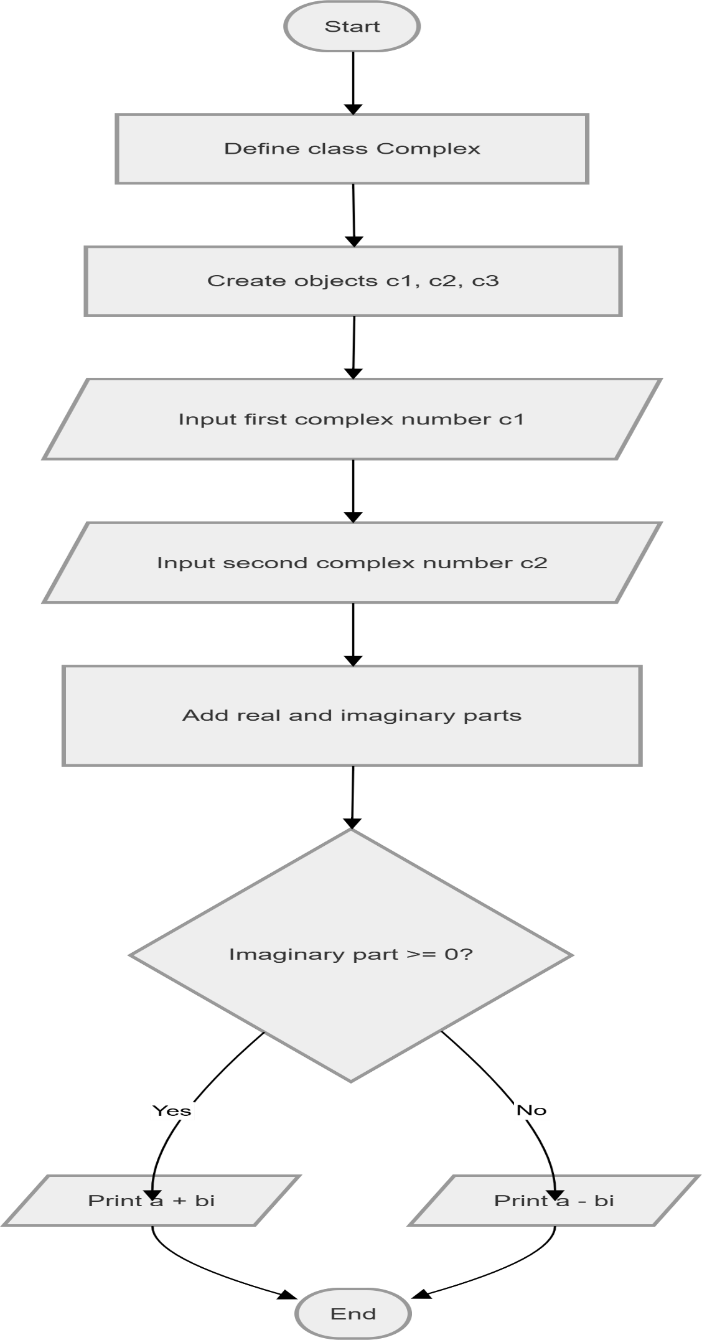

C] code: class Complex:
def initComplex(self):
self.real,self.imag = map(int,input().split())

def sum(self,C1,C2):
self.real = C1.real + C2.real self.imag = C1.imag + C2.imag

def display(self):
if self.imag>= 0:
print(f"{self.real} + {self.imag}i")
else:
print(f"{self.real} - {abs(self.imag)}i")

# Create three instances c1 = Complex() c2 = Complex() c3 = Complex()

# Initialize two complex numbers c1.initComplex() c2.initComplex()

# Compute and display sum c3.sum(c1, c2) c3.display() D]CODETANTRA:

